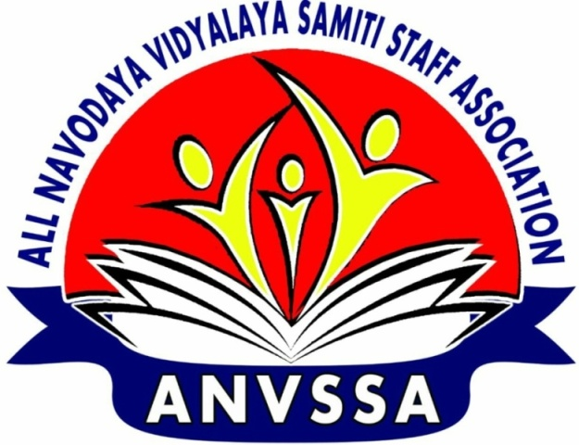
ALL NAVODAYA VIDYALAYA SAMITI STAFF ASSOCIATION (ANVSSA)
(Regd No: 639 of 2017)
President General Secretary
K. Manjula : 9494285645 Tafseer Anwer : 9935555002

F-ANVSSACEC/CCS PENSION/2018-19/JULY/71 Date: 01.08.2018
Honourary President
L.B.REDDY
Legal Advisor
S.S.DORA
ASSOCIATE PRESIDENTS
N.P.MEHAR
K.M.REDDY
G.S.BASAVARAJU
U.K.VARMA

VICE PRESIDENTS
SHAIK MAROOF
HARIHAR RAI
K P. KORI
MRIDULCHAKRABORTY
DR. S.K.SINHA
P.K.MISHRA
R.S.RATHODE

DY GEN SECRETARIES
K.T.PRASAD
R.P.SHARMA
SHAMBHU PRASAD
U.G. SONPARKHE
SHAFI KAMAL

SECRETARIES
PRAHARAJ
SANJEEV KUMAR SINGH
S.K.ANANT
SOMNATH CHAKRABORTY
K.G.PRATIBHA
K.V.THOMAS
BHUVANESH KUMAR

REGNL ORG SEC
SAROJINI NADA GOWDA
RAVINDER KUMAR
R.K.MAGARIA
R.S.TOMAR
JYOTHI PANWAR
S.K.JHA
J.C.KONWAR
SITA RAM BANSAL

TREASURER
ZUBAIR ALI KHAN

PRESS SECRETARIES
- BRIJMOHAN MEENA
- A.K.JHA

APPEAL TO THE PRINCIPALS & VICE-PRINCIPALS OF ALL JNVS
Dear Sir/Madam
For decades we all have been making relentless efforts to achieve CCS Pension for all the staff working in our organization. The urgency and anxiety of the staff have even compelled us to knock on the doors of legal bodies, finally the apex court also but the verdict was not in our favour though our demand was just.
There is little doubt that our demand for pension is most justifiable. There are few organizations in the entire country where the expectations from the employees are as challenging as in our organization. The pressure on the staff for excellence in academic areas is continual and ever rising. Working in the organization is perennial challenge. The reputation of Jawahar Navodaya Vidyalayas as centres of academic excellence is due to the untiring dedicated work of all of us under most tiring conditions. The extraordinary work of the staff has won accolades of Y.N.Chanturvedi Committee to Niti Aayog. It is tragic to see such selfless work go unsatisfactorily rewarded.
The Association has launched fresh efforts to appraise the government of India of injustice meted out to the 12,000 odd NVS employees as the CCS Pension 1972 benefits are denied to them on the grounds that NVS came into existence after the cut off date for the old pension benefit, i.e. 010-01-1986. The fact is that the Ministry of HRD got approval for setting up two Model Schools, one at Amaravati (Maharastra) and another at Jajjar (Haryana), from the finance Ministry and notified the launching of them in October 1985 itself. Funds were released to NCERT, which was temporarily asked to monitor the schools till a suitable autonomous body was formed to run the schools on permanent basis. The Association has not given up the demand despite setbacks in the courts. The latest delegation led by the undersigned met a number of MPs\Cabinet Ministers and submitted memoranda. The headquarters is also making efforts for the approval of our demand by the finance ministry.
At this juncture, there is a strong urgency to impress and exert pressure on the Finance Ministry on our part. The Association humbly requests the Principals & Vice-Principals to rise to the occasion by meeting the MPs under whose jurisdiction their schools exist. It further appeals to them to appraise the MPs of the role of the vidyalayas in rural empowerment and nation-building and obtain their letter in support of our demand for pension. They may also ensure that the same are sent to the Finance Ministry without delay. The Finance Ministry should be made to realise that our demand is no longer a marginal issue but it has acquired wider sympathy and publicity.
The Association encloses herewith a model representation to be sent by the MPs to the Prime Minister, the Finance Minister and the Minister for HRD. The Principals & Vice-Principals may also prepare contents of the letters themselves and request the MPs to reflect the same in their letters.
Thanking you,
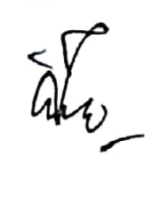
Yours sincerely
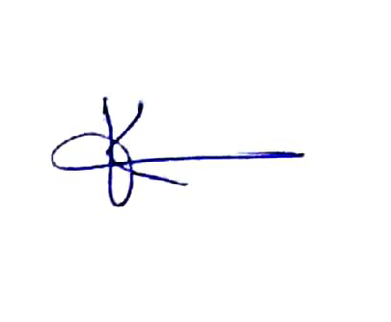

K.MANJULA TAFSEER ANWER
President General Secretary

Contd...Page-2

Dear All,
It is time once again to bring pressure on the Govt. of India to listen to our long-pending grievances by meeting the Members of Parliament under whose purview our JNVs function. In this connection, you are requested to pursue the following action plan.
- Take a print of attached document “ Representation to MP”.
- After taking a printout, submit a signed copy to the local Member of Parliament (Lok Sabha/Rajya Sabha).
- Also download “Letter to PM, MHRD/MoF” into a pendrive/personal e-mail. When your delegation meets the MP, request the office there to prepare a letter on behalf of the MP with the contents from our letter. If they forward our representation, it is still fine. Request the office to forward the signed letter of the MP to the Hon’ble PM/MHRD/MoF. If the office gives you a copy of the letter by hand, please take pains to post the letter to the above offices yourself.
- Addresses of the PMO/MHRD/MoF & email IDs:
Kindly mail a pdf copy of the MPs letter to the association’s mail “ cecanvssa@gmail.com” to enable it to put it on the website. We invite your feedback.
ADDRESSES:- 1) PRIME MINISTER:
Shri.Narendra Modi ji,
Hone’ble Prime Minister,
SOUTH BLOCK,
RAISINA HILL, NEW DELHI-110011
FAX: +91-11—233-019545-23016851
e-mail: connect@gov.nic.in, nrendramodi1234@gmail.com

2)MINISTER OF HRD:
Shri.Prakash Javdekar ji,
Hon’ble Minister of HRD,
Shastri Bhavan,
NEW DELHI-110001
FAX: +91-11-23382365
e-mail: minister.hrd@gov.in

3)MINISTER OF FINANCE:
Shri.Arun Jaitley ji,
Hon’ble Minister of Finance,
JEEVAN DEEPBUILDINGS,SANSAD MARG,
NEW DELHI—110001
FAX: +91-11-23794556
e-mail: office@arunjaitley.com

